database

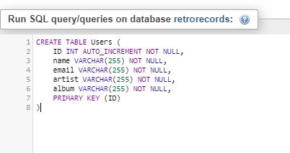

**Creating records Table**

 CREATE TABLE records (

     ID INT NOT NULL AUTO_INCREMENT,

     Name VARCHAR(255) NOT NULL,

     ContactName VARCHAR(255) NOT NULL,

     Address VARCHAR(255) NOT NULL,

     City VARCHAR(255) NOT NULL,

     PostalCode VARCHAR(255) NOT NULL,

     Country VARCHAR(255) NOT NULL,

     Phone VARCHAR(255) NOT NULL,

     PRIMARY KEY (ID)

)

CREATE TABLE records(

ID INT AUTO_INCREMENT NOT NULL,

albumImage VARCHAR(255) NOT NULL,

artist VARCHAR(255) NOT NULL,

price DOUBLE(4,2) NOT NULL,

PRIMARY KEY (ID)

)

CREATE TABLE customers (

ID int NOT NULL PRIMARY KEY AUTO_INCREMENT,

Name varchar(255) NOT NULL,

ContactName varchar(255) NOT NULL,

Address varchar(255) NOT NULL,

City varchar(255) NOT NULL,

PostalCode varchar(255) NOT NULL,

Country varchar(255) NOT NULL

)